

**ONLINE COMPLAINT SYSTEM**

**A PROJECT REPORT**

***Submitted By***

Md. Jahidul Islam

ID: EMCS0708054

Sharmin Akter

ID: EMCS0708041

***in partial fulfillment for the award of the degree***

***of***

**MASTER OF SCIENCE**

**IN**

**DEPARTMENT OF COMPUTER SCIENCE AND**

**ENGINEERING**

**COMILLA UNIVERSITY: COMILLA-3506**

**August, 2023**

**COMILLA UNIVERSITY: COMILLA-3506**

**BONAFIDE CERTIFICATE**

Certified that this project report **“Online Complaint System”** is the bonafide work of **“Md. Jahidul Islam, Sharmin Akter”** who carried out the project work under my supervision.

**Signature**

Khalil Ahammad

**SUPERVISOR**

Department of Computer Science and Engineering

Comilla University

Dr. Mahmudul Hasan

**CHAIRMAN OF THE EXAM COMMITTEE**

Department of Computer Science and Engineering

Comilla University

**Signature**

# **Abstract**

The "Online Complaint System" is a web-based application. It is designed to address the problems of the day-to-day life of the citizens of a Powrashava or a City corporation, by bringing them to the notice of the appropriate parties.

In today's world of technology, everyone has a smartphone. This is our attempt to improve the human life system by using this technology. Since anyone can complain here and no one has to go to another office for this, it saves both time and money. Moreover, pictures or necessary documents can be attached to each report which is not possible in the traditional way. Having more facts makes it take less time to solve the problem. Because it is web-based, every moment updates are notified to the complainant. At the same time, since other people can see all the activities, it is going to ensure the transparency of the corporation.

# **Acknowledgments**

First and foremost, we would like to thank the Almighty ALLAH for the gift of life, intelligence, and understanding that he has bestowed upon us, providing a reason for our existence. And to r families for their unwavering love and support throughout our lives.

We thank Tazkia Binty Faruqui, who we consider to be our mentor and supervisor, for his knowledge and intellect in supervising this project. This excellent effort, we believe, is the product of his excellent supervision and cooperation.

Finally, we'd want to express our gratitude to our faculty’s instructors for their excellent work over our four years of study. May ALLAH bless them and protect them. We all adore you.

**Table of Contents**

**Abstract** i

**Acknowledgments** ii

**List of Figure** vi

**Chapter 1** 1

**Introduction** 1

**1.1 Objective** 1

**1.2 Motivation** 1

**Chapter 2** 2

**Literature Review** 2

**2.1 Literature Overview** 2

**2.2 System Analysis** 2

**2.3 Proposed System** 2

**2.4 Complainant Requirements** 2

**2.5 Hardware and Software Specification** 3

**2.5.1 Hardware Specification** 3

**2.5.2 Software Requirements** 3

**Chapter 3** 4

**Methodology and Design** 4

**3.1 Use case Diagram** 4

**3.1.1 Overall Use Case** 5

**3.1.2 Complainant Use Case** 6

**3.1.3 Divisional Officer Use Case** 7

**3.1.4 Administration Use case** 8

**3.2 ER-Diagram** 9

**Chapter 4** 10

**Database Design** 10

**4.1 Table List** 10

**4.2 AspNetUser Table** 11

**4.3 AspNetRoles Table** 12

**4.4 AspNetUserRoles Table** 12

**4.5 Questions Table** 13

**4.6 Answers Table** 13

**4.7 AboutInfos Table** 14

**4.8 Contacts Table** 14

**Chapter 5** 15

**Implementation Result** 15

**5.1 Index Page** 15

**5.2 View Complain Page** 16

**5.3 Complaint by Division Page** 18

**5.4 Submit Complain Page** 19

**5.5 Contact Page** 20

**5.6 Login Page** 22

**5.7 Accounts Page** 23

**5.8 Division Page** 24

**5.9 Assign Division to Accounts** 24

**5.10 All Complaint Page** 25

**5.11 Messages Page** 26

**5.12 Application Information Page** 26

**Chapter 6** 27

**Appendix** 27

**6.1 Code Listings** 27

**6.2 Software Repository** 28

**Chapter 7** 29

**Conclusions and Limitations** 29

**7.1 Suggestion for Feature Work** 29

**7.2 Conclusions** 29

**7.3 Limitations** 29

**References** 30

# **List of Figure**

Figure 3.1. 1 Overall use case 5

Figure 3.1. 2 Complainant use case 6

Figure 3.1. 3 Divisional Officers use case 7

Figure 3.1. 4 Admin use case 8

Figure 3.2. 1 ER-Diagram 9

Figure 4. 1 Table list 10

Figure 4. 2 AspNetUser table 11

Figure 4. 3 AspNetRoles table 12

Figure 4. 4 AspNetUserRoles table 12

Figure 4. 5 Question table 13

Figure 4. 6 Answers table 13

Figure 4. 7 AboutInfos table 14

Figure 4. 8 Contacts table 14

Figure 5.1. 1 Welcome e section 15

Figure 5.1. 2 Report section 15

Figure 5.1. 3 Footer section 16

Figure 5.2. 1 View complain page 16

Figure 5.2. 2 Response section 17

Figure 5.2. 3 Respond to the complaint 17

Figure 5.3. 1 Hovered menu 18

Figure 5.3. 2 Complain by division 19

Figure 5.4. 1 Submit complaint 20

Figure 5.5. 1 Contact page 21

Figure 5.6. 1 Login page 22

Figure 5.6. 2 Slider login 22

Figure 5.6. 3 Post login options 22

Figure 5.7. 1 Account page 23

Figure 5.7. 2 Add account modal 23

Figure 5.8. 1 Division page 24

Figure 5.9. 1 Assign division to account 24

Figure 5.10. 1 All Complaint 25

Figure 5.10. 2 Complaints view Divisional officers 25

Figure 5.11. 1 Messages page 26

Figure 5.12. 1 Application information 26

# **Chapter 1**

# **Introduction**

This software can be used to report the problems of day-to-day life to the appropriate authority. Users can see submit a report as well as check previous reports or responses. This system involves three groups of people’s Complainants, Divisional officers, and Administrators. The best refinement is going to be ensured as the reports are divided by department. Each department will take care of the complaints under their department only. One section will not see the report of another section. Divisional officers can respond to reports but can’t delete any reports. All reports initially will go through the approval process to avoid spam or offensive report.

## **1.1 Objective**

The application will allow users to submit reports without an account. Instead, it will collect their name, phone number, and address to verify or further communicate.

## **1.2 Motivation**

We are often faced with various problems but due to lack of time or any other reason, the authorities are not informed. In this way, those problems are avoided by the authorities. As a result, these problems are not solved or it is too late. Again, it is often seen that many people do not want to get into official trouble. So do not open your mouth amid hundreds of problems. Our goal is to solve the problems of these people. As well as building a system that is suitable for all people who use smartphones or computers. Using this system will not only make it easier to complain but will also save both time and money. They will be able to take swift action as soon as they come to the notice of the authorities, which will reduce the suffering of the people as well as increase the acceptability of the other side.

# **Chapter 2**

# **Literature Review**

## **2.1 Literature Overview**

From this project, we may expect to design and implement new links, as well as design and implement users and organize new links by subject.

## **2.2 System Analysis**

A system analysis will be conducted to see if it is possible to create information based on the organization's rules and strategies as well as user requirements, as well as to identify and eradicate the current system's flaws. The new system should be cost-effective, increase management, productivity, and services, improve user/system interface, improve system dependability, availability, flexibility, and expansion potential, and improve data quality and usability.

## **2.3 Proposed System**

The proposed system is primarily designed to receive complaints at the grassroots level of an organization and ensure maximum service through resolving them. It makes tasks lots easier for the both complainant and the authorities. It reduces the time required to solve an issue and saves time and money. This app has a user-friendly and easy user interface on both desktop and native levels.

## **2.4 Complainant Requirements**

1. No accounts are required to submit a report
2. Complainant can view their report after approval
3. Complainant can check responder profile
4. Complainant can view previous reports submitted by others
5. Complainant personal information will be hidden from the public as well as divisional officers.

## **2.5 Hardware and Software Specification**

### **2.5.1 Hardware Specification**

* Processor 🡪Intel Celeron
* Processor Speed 🡪700 MHz
* RAM 🡪1 GB
* Hard disk 🡪5GB

### **2.5.2 Software Requirements**

* Operating System 🡪 Windows 7 SP1+/8.1/10/11/ Mac/ Linux
* Database 🡪 SQL
* Server-side Technology 🡪 ASP.Net Core
* Server-side Scripting 🡪 C#, SQL (MSSQL)
* Client-side Scripting 🡪 HTML5, CSS3, Bootstrap, JavaScript

# **Chapter 3**

# **Methodology and Design**

## **3.1 Use case Diagram**

C# (C-Sharp) is a general-purpose, multi-paradigm programming language developed by Microsoft that runs on the .NET Framework. C# is widely used for building mobile applications, games, and windows applications.

With the help of the C# programming language, we can develop different types of secured and robust applications:

* Window applications
* Web applications
* Distributed applications
* Web service applications
* Database applications etc.

This application is a web application. We’ve used. NET’s latest release ASP .Net Core 6 and Entity Framework Core 6 on this application.

C# is approved as a standard by ECMA and ISO. C# is designed for CLI (Common Language Infrastructure). CLI is a specification that describes executable code and runtime environment.

C# programming language is influenced by C++, Java, Eiffel, Modula-3, Pascal, etc. languages.

### **3.1.1 Overall Use Case**

In this diagram, the general purpose of the application has been shown.

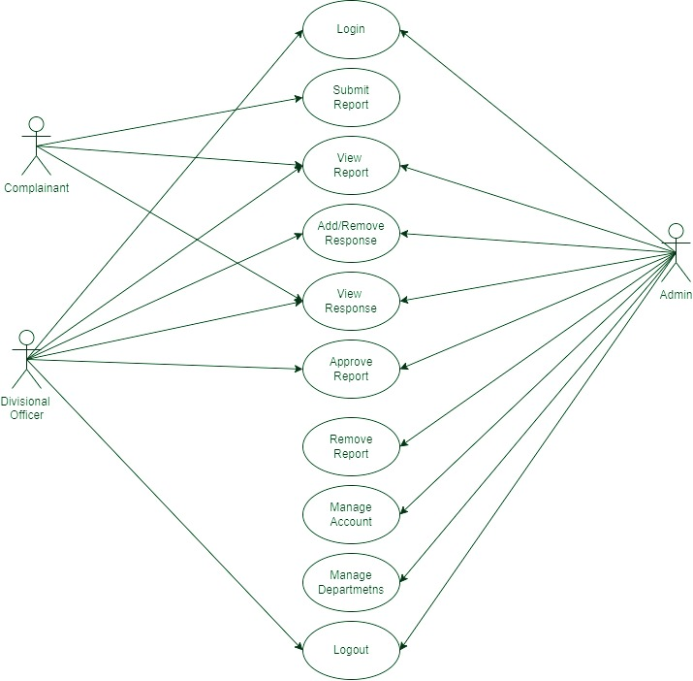

Figure 3.1.1Overall use case

### **3.1.2 Complainant Use Case**

The purpose of a complainant has shown in the diagram. A complainant can submit a report, view a report and respond.

Figure 3.1.2 Complainant use case

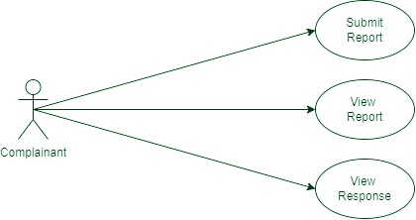

### **3.1.3 Divisional Officer Use Case**

The purpose of divisional officers has shown in the diagram. A divisional officer can log in, view the report, add or remove the response, view the response, approve the report, and log out.

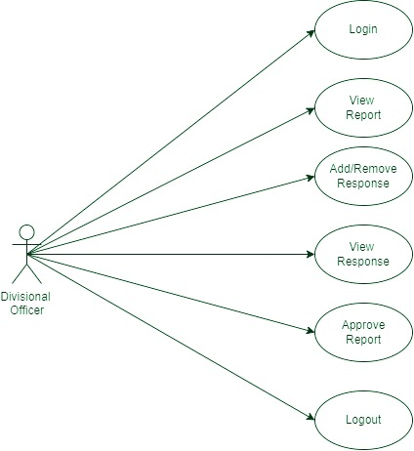

Figure 3.1.3Divisional Officers use case

### **3.1.4 Administration Use case**

The purpose of administration has shown in the diagram. An admin can log in, view reports, add or remove responses, view responses, approve the report, remove the report, manage the account, manage a department, and log out.

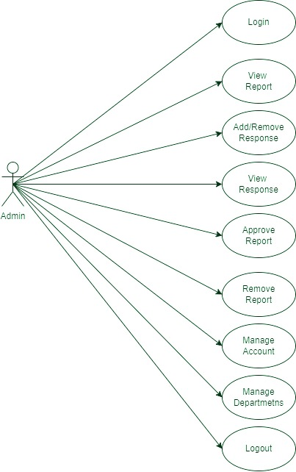

Figure 3.1.4 Admin use case

## **3.2 ER-Diagram**

In this diagram, we can see the connection between user flow and data flow. And theirattributes also.

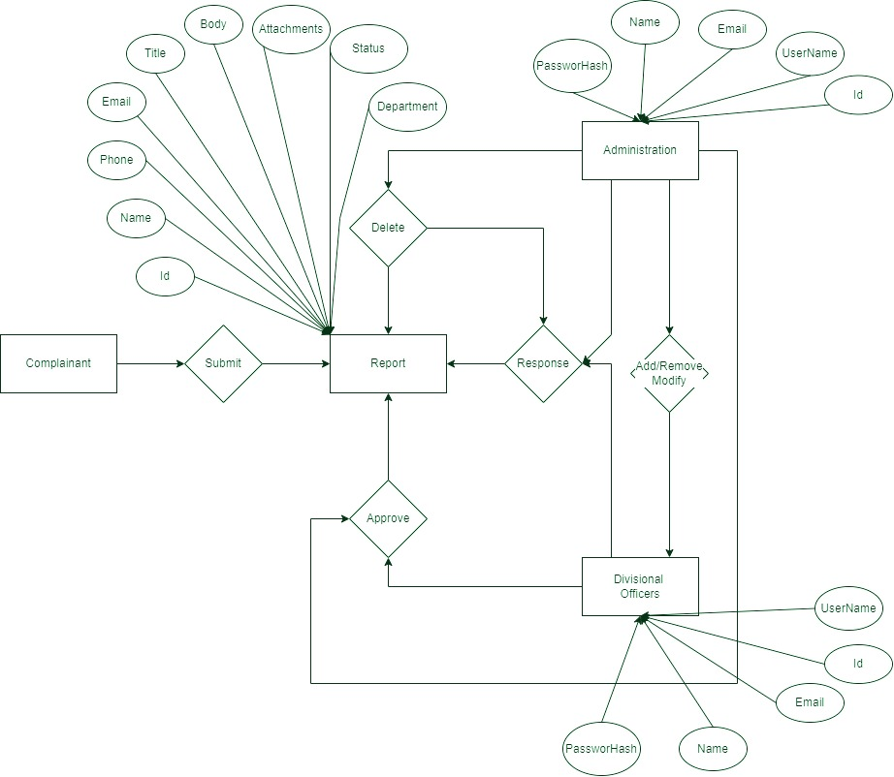

Figure 3.2.1 ER-Diagram

# **Chapter 4**

# **Database Design**

## **4.1 Table List**

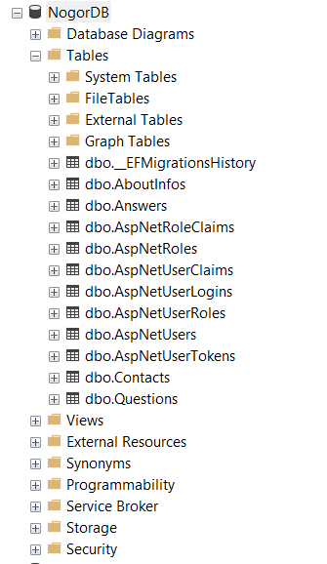

Figure 4.1 Table list

## **4.2 AspNetUser Table**

Since this application uses ASP .Net Core, Entity Framework Core so we use ASP .Net Identity for Authentication. We also use Authorization to define the account’s role. All of our Administration and Divisional Officers account are stored here.

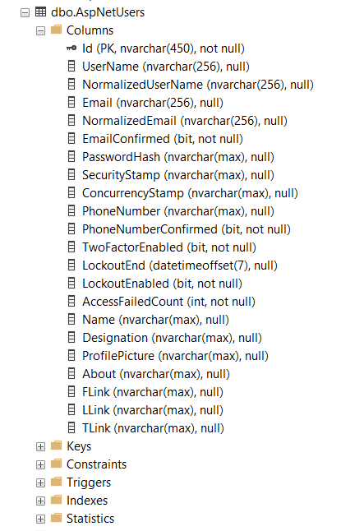

Figure 4.2AspNetUser table

## **4.3 AspNetRoles Table**

AspNetRoles holds all roles such as Administrators or divisions in which we assign users later.

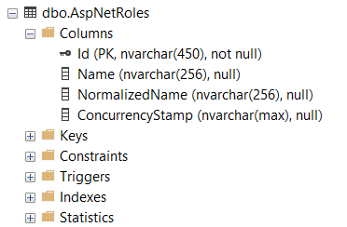

Figure 4.3AspNetRoles table

## **4.4 AspNetUserRoles Table**

AspNetUserRoles holds the record of the assigned role to the user. One user can be assigned to multiple roles.

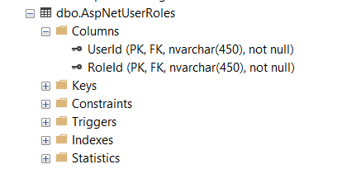

Figure 4.4AspNetUserRoles table

## **4.5 Questions Table**

All submitted complaints will be stored in this table.

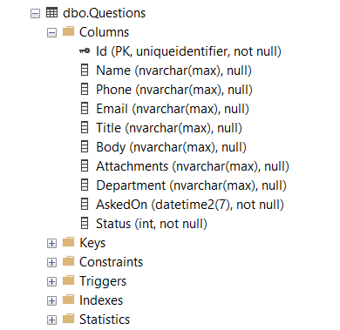

Figure 4.5 Question table

## **4.6 Answers Table**

All responses against complaints will store here.

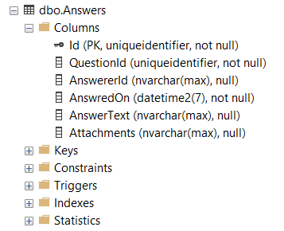

Figure 4.6 Answers table

## **4.7 AboutInfos Table**

The information on the application is stored here. Such as address, phone, email, application logo, map location, description.

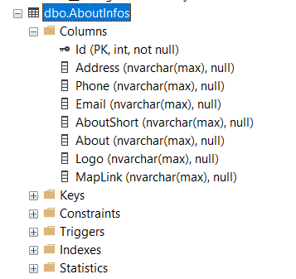

Figure 4.7AboutInfos table

## **4.8 Contacts Table**

The messages which have been sent from the application contact form will store here.

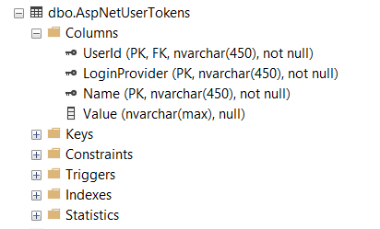

Figure 4. Contacts table

# **Chapter 5**

# **Implementation Result**

## **5.1 Index Page**

The index page is an action result from HomeController where we have a method type of IActionResult and this is the view. On the home page, we have a simple welcome message and all recent report is being rendered underneath it. On top of that, we have a navigation menu and search box.

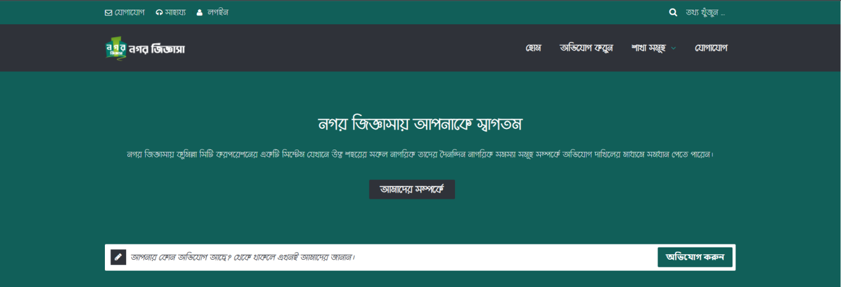

Figure 5.1.1 Welcome e section

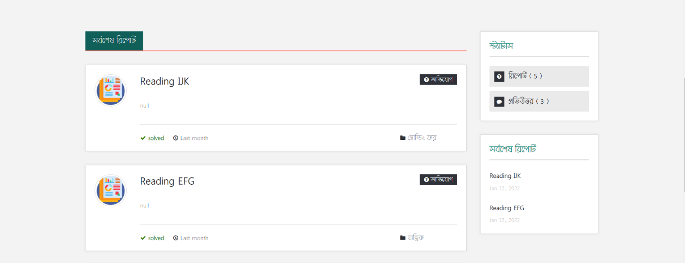After that the report section start. Here all recently approved reports will be shown. On the left side of the section, there is a sidebar, where counted number of reports and responses are shown. Under that last two reports will display. This sidebar is common for every view (page).t

Figure 5.1. Report section

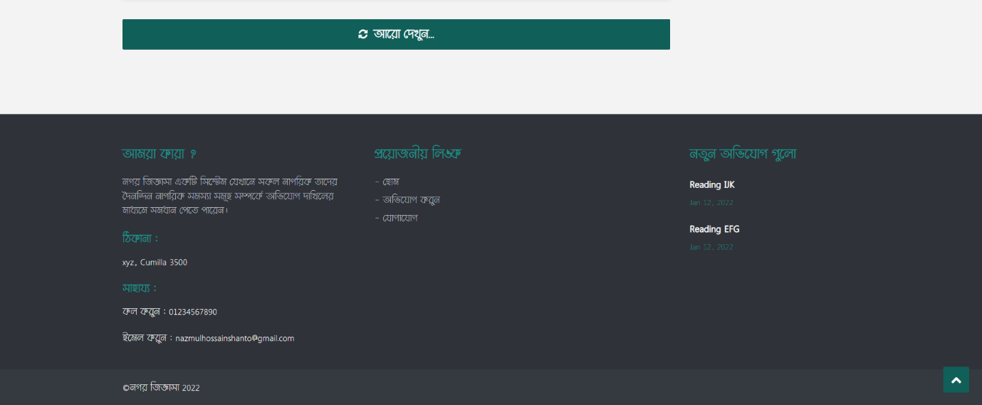At the end of the report section, we have a “load more” button. By clicking these 3 more reports will render at the top of the button if exist on the database. After that, the footer section began. In the footer, there is some contact information and navigation links.

Figure 5.1. Footer section

## **5.2 View Complain Page**

This page is another controller action page. QuestionController is the controller and IActionResultViewReport is the method is responsible for this view. The complaint is queried by Id (type Guid) and displayed here.

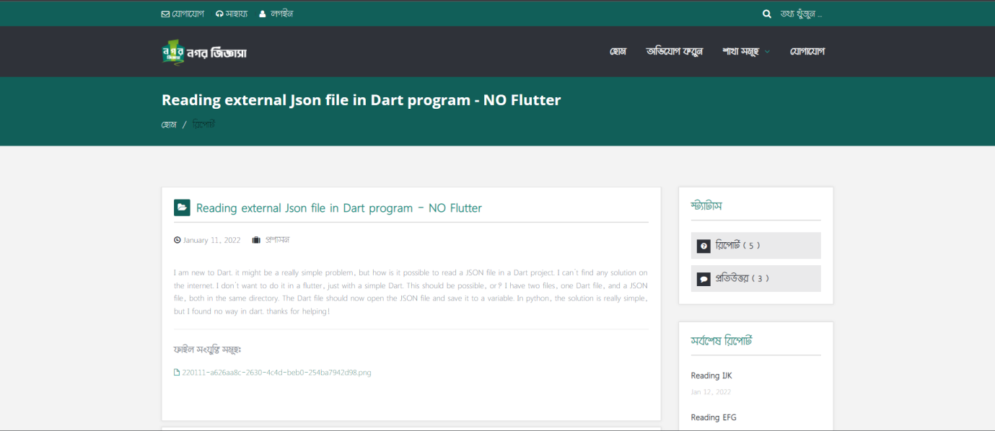

Figure 5.2.1 View complain page

Underneath the report, there is another section which is the response section. All responses will be displayed here.

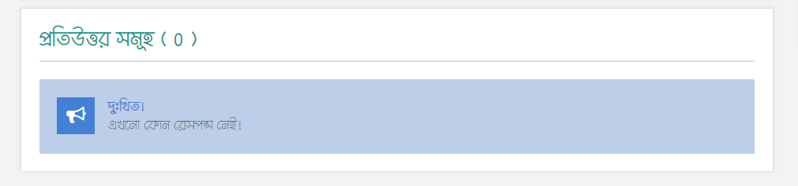

Figure 5.2.2 Response section

When an administrator or divisional office will log in there will appear another section to respond to the complaint. This section will normally be hidden from the end-user until he/she is not logged in to any account.

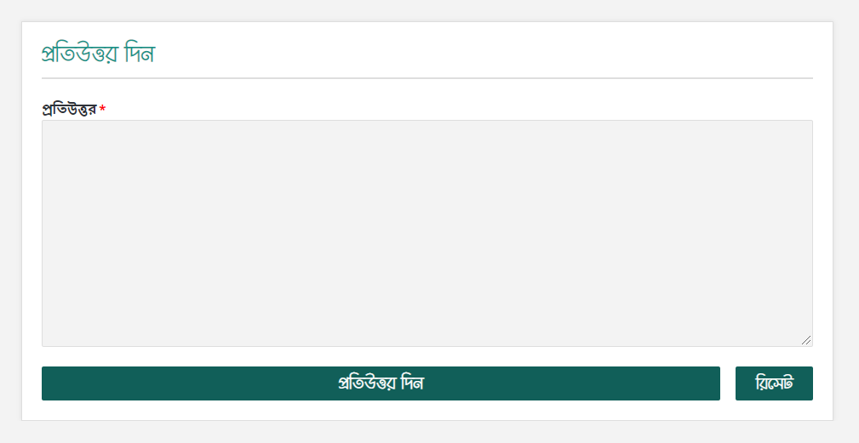

Figure 5.2.3 Respond to the complaint

## **5.3 Complaint by Division Page**

In this ActionResult page, the complaint will be categorized by division which was selected by the complainant. By hovering the mouse cursor on “Divisions” on the navigation menu the list of divisions will appear. By clicking those links user will land on this page.

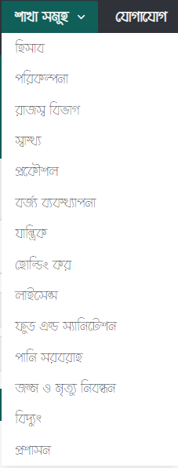

Figure 5.3.1 Hovered menu

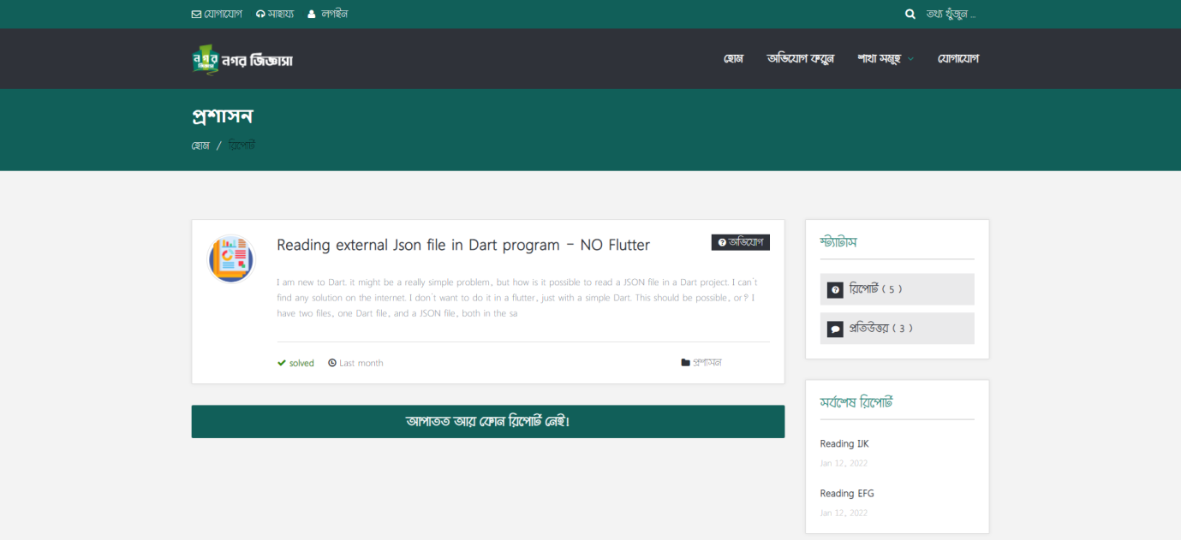

Figure 5.3.2 Complain by division

## **5.4 Submit Complain Page**

From here users can submit complaints. Individual division can be selected while submitting.

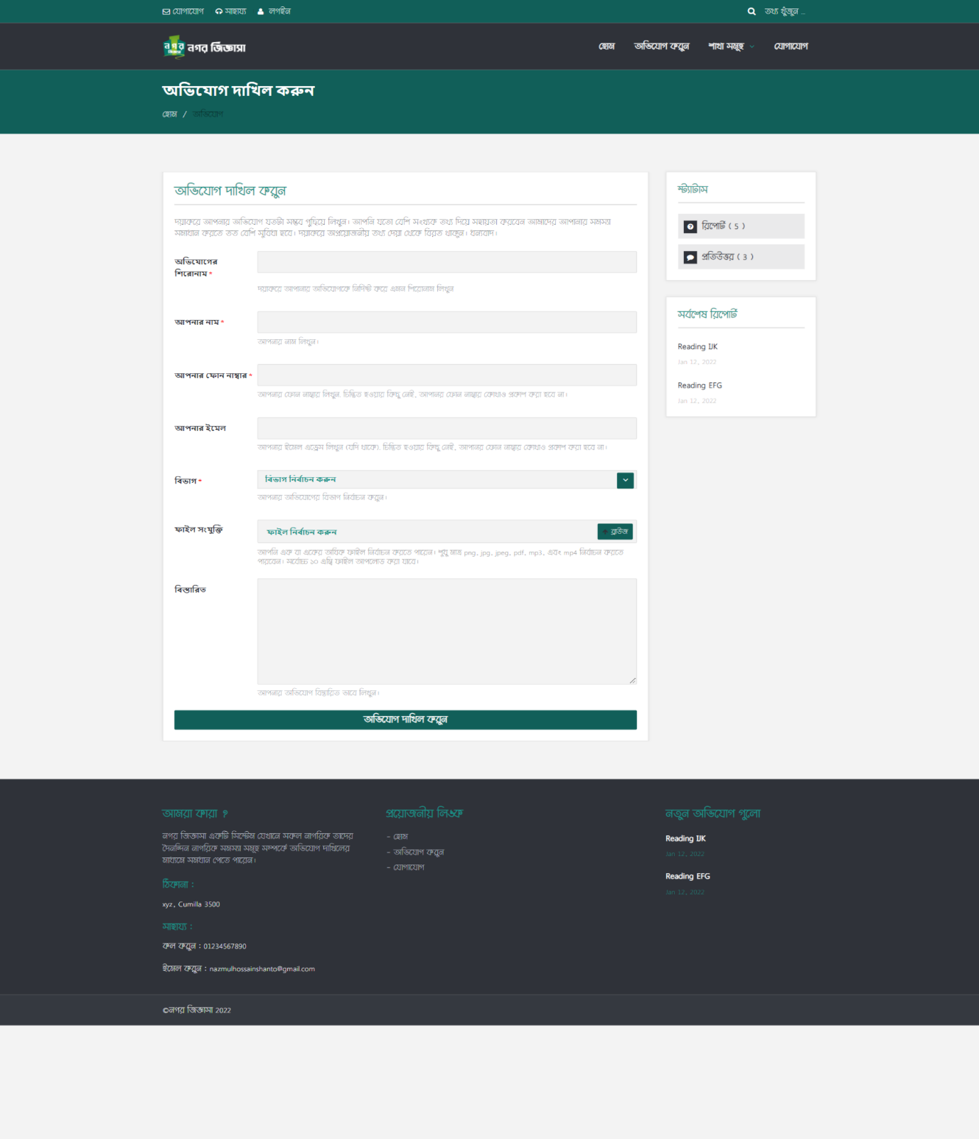

Figure 5.4. Submit complaint

## **5.5 Contact Page**

This page is an ActionResult from HomeContoller. Here users can communicate with authority by sending messages. An embedded map is also displayed here. About information is displayed beside the contact form.

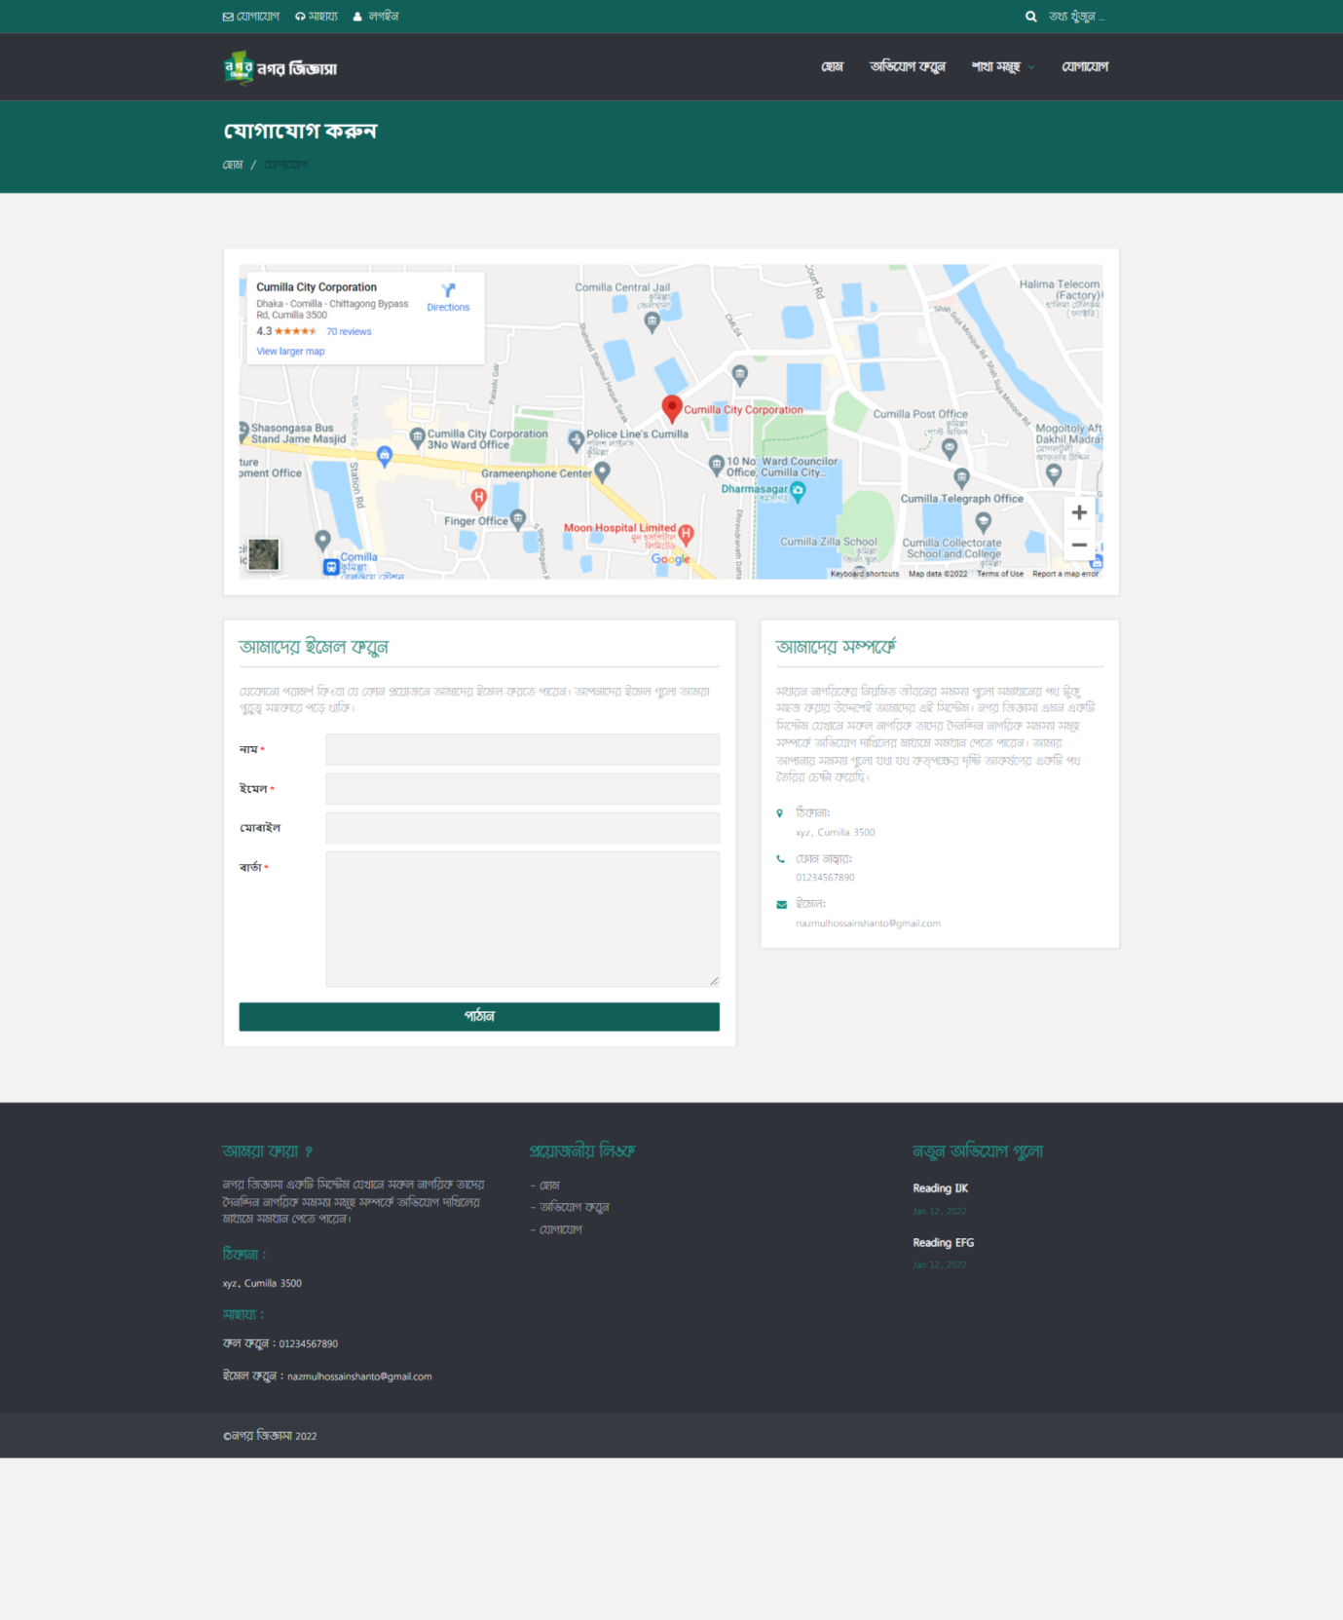

Figure 5.5.1 Contact page

## **5.6 Login Page**

The login page is an IActionResult form AccountController.

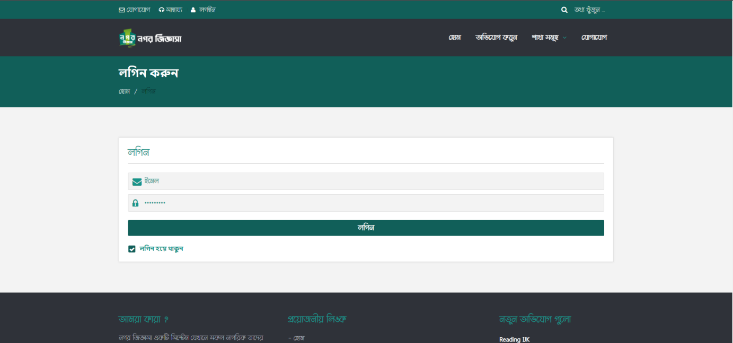

Figure 5.6.1Login page

We also have a slider login menu at the header of the application.

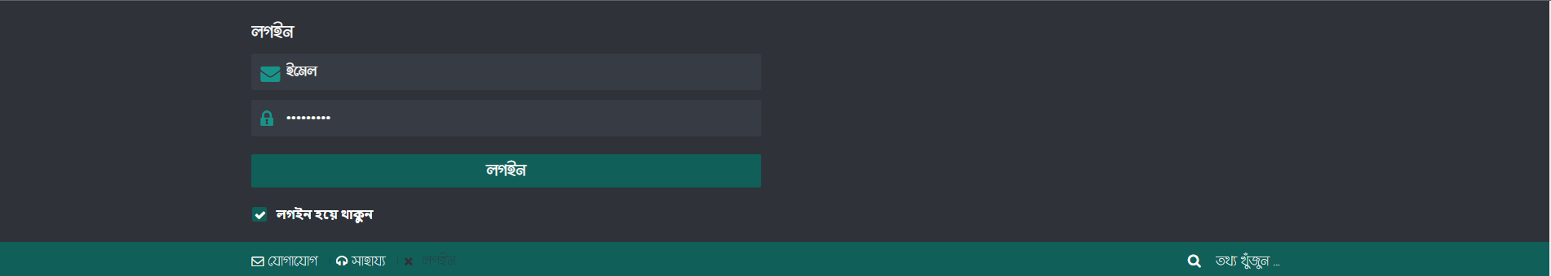

Figure 5.6.2Slider login

After login few more options will appear in the top navigation.



Figure 5.6.3Post login options

## **5.7 Accounts Page**

From here a new account can be created, update, or can be deleted. This action on available form those are in Administration role.

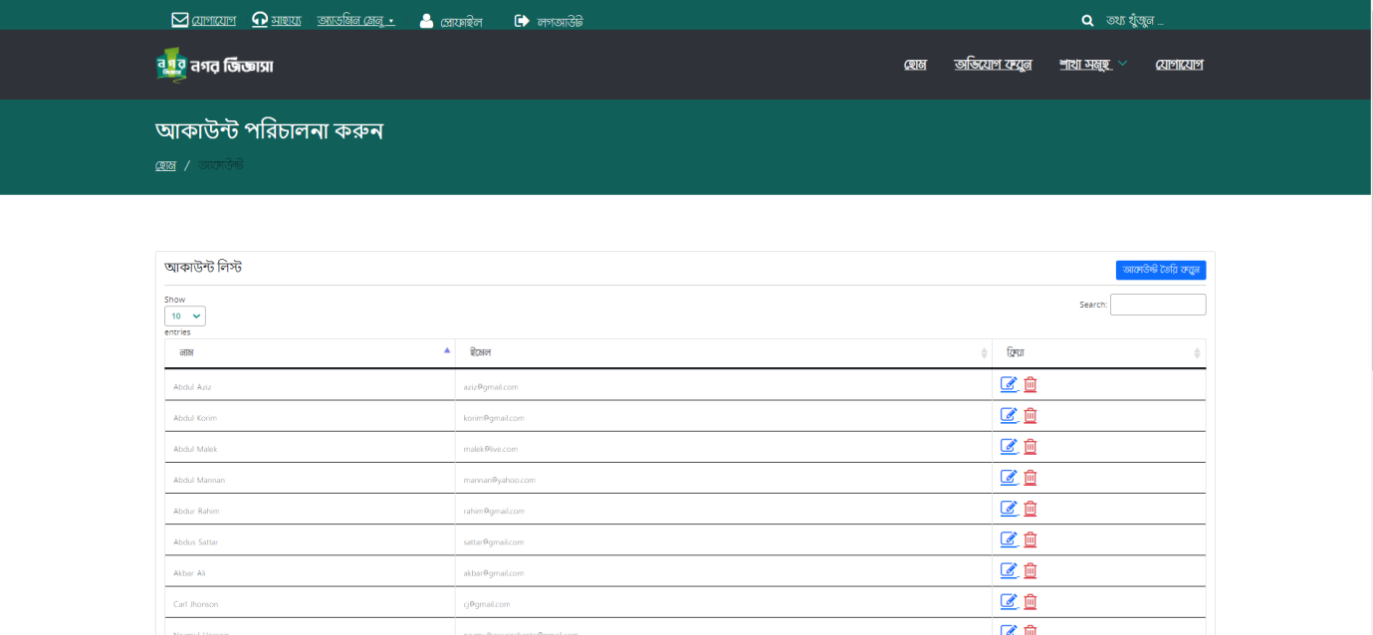

Figure 5.7.1Account page

By clicking add account button a modal will appear. From there a new account can be created. Edit and delete can be done as well.

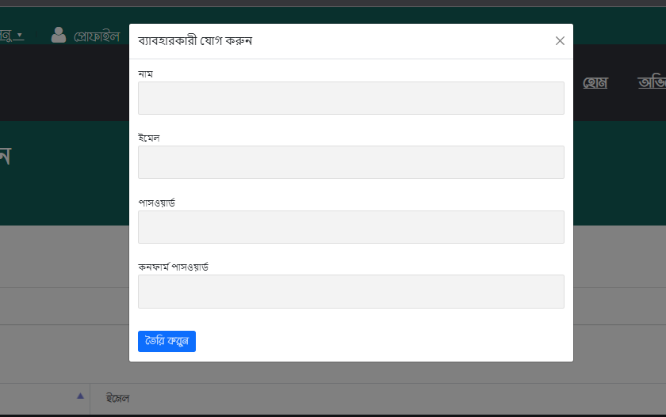

Figure 5.7.2Add account modal

## **5.8 Division Page**

From this page, division can be managed. This division will be assigned to users to handle the complaint department-wise.

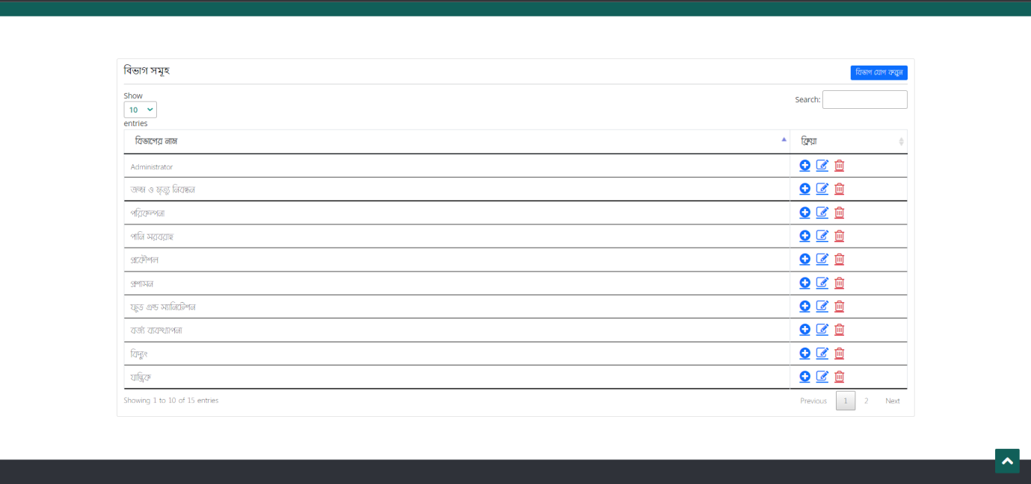

Figure 5.8.1 Division page

## **5.9 Assign Division to Accounts**

Form here division will be assigned to one or multiple accounts.

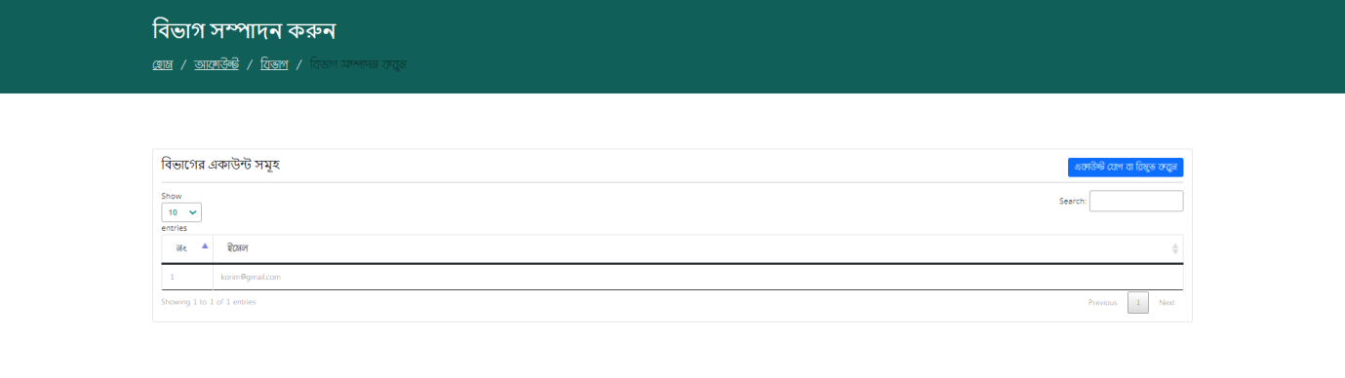

Figure 5.9.1 Assign division to account

## **5.10 All Complaint Page**

The administrator can view all the complaints from here. The administrator can approve complaints, or delete complaints.

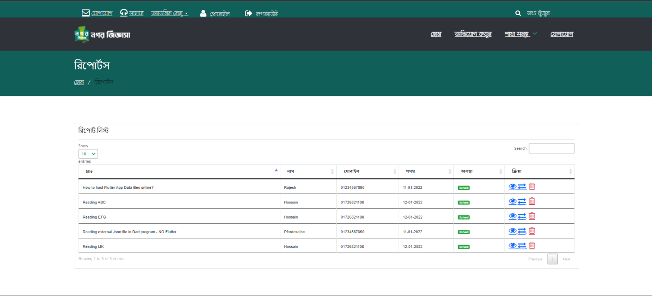

Figure 5.10.1 All Complaint

The divisional officer will have access only to their department complaints. They can check those from their profile.

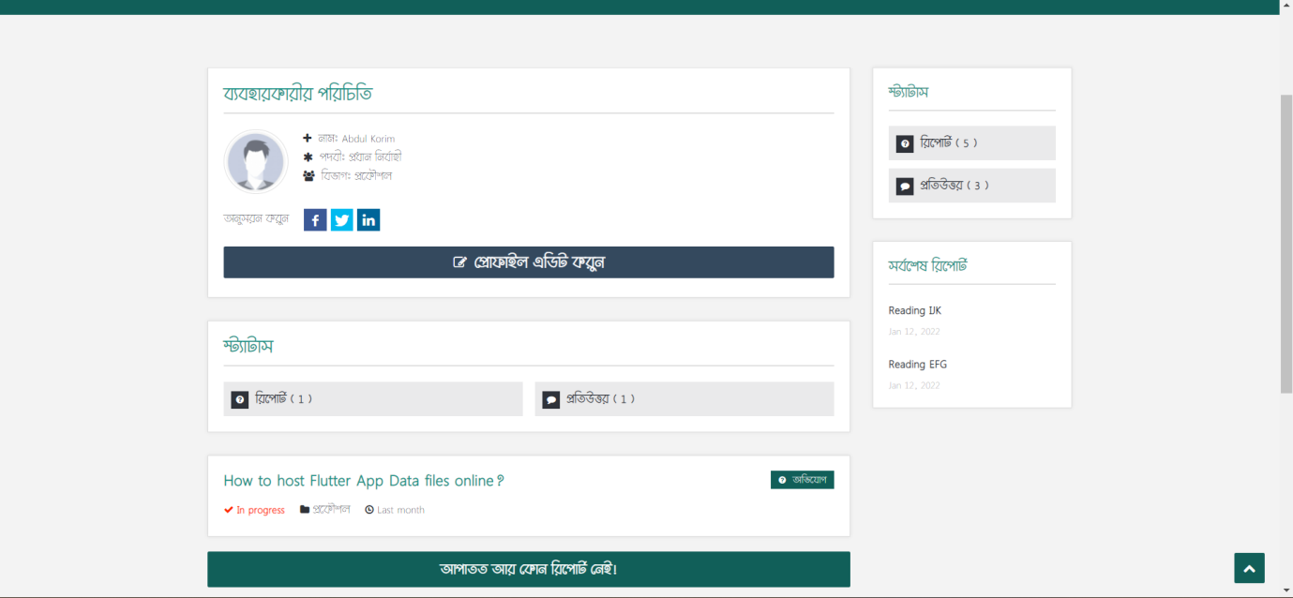

Figure 5.10.2 Complaints view Divisional officers

## **5.11 Messages Page**

From here administration can check all messages sent by contact form.

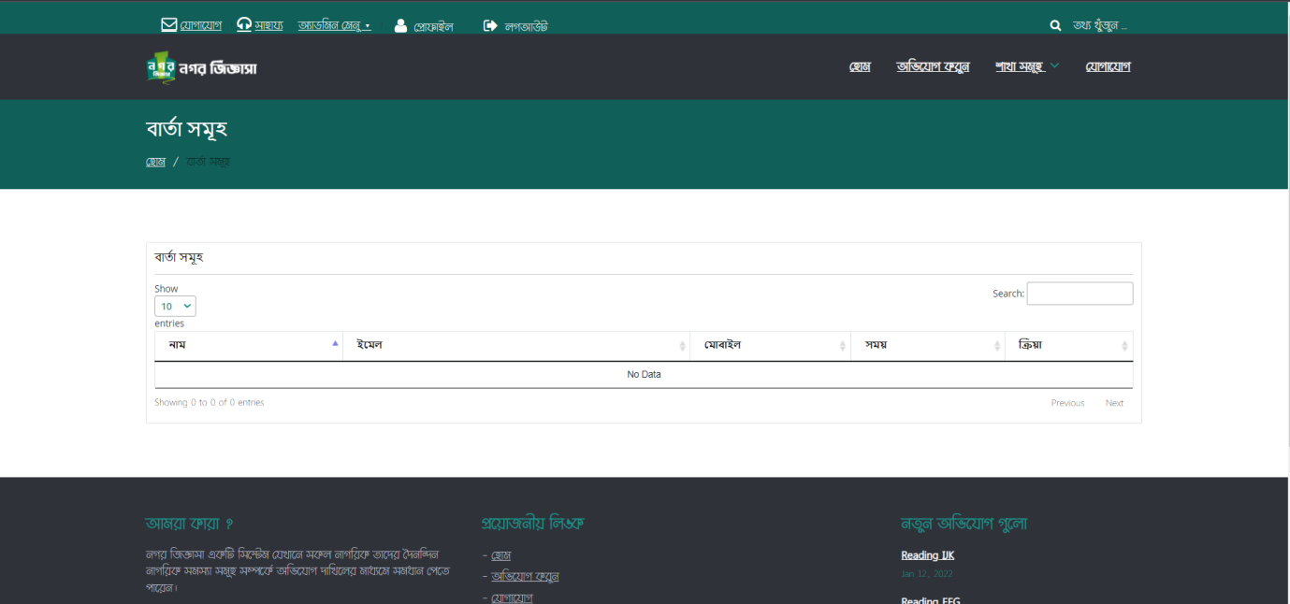

Figure 5.11.1 Messages page

## **5.12 Application Information Page**

Form here all application information can be managed.

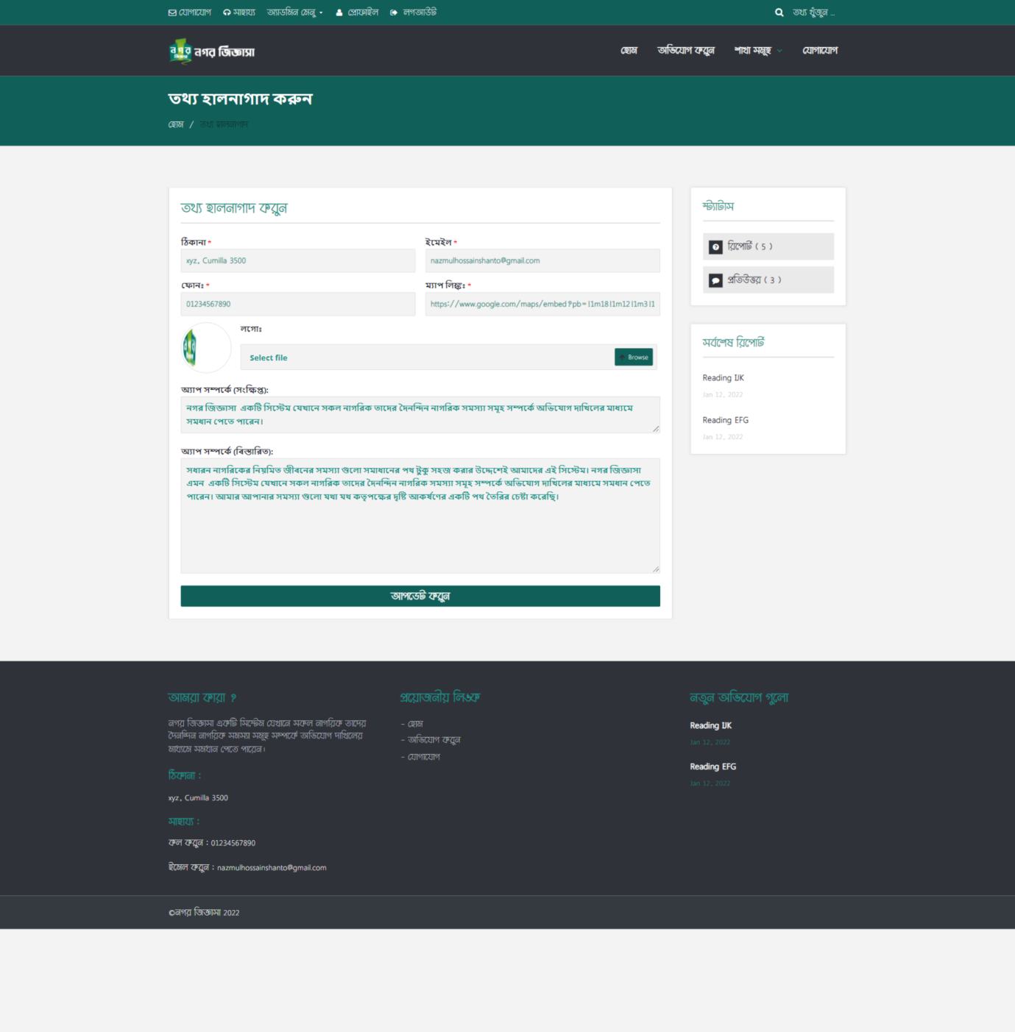

Figure 5.12.1 Application information

# **Chapter 6**

# **Appendix**

## **6.1 Code Listings**

Application Configuration Part

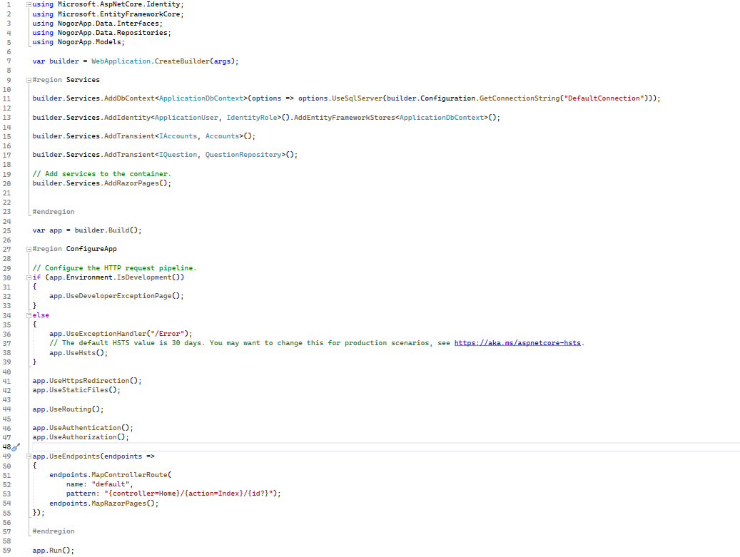

## **6.2 Software Repository**

The complete source code, documentation, and related files for the software developed in this project are available in the public software repository hosted on GitHub.

Repository Name: NogorApp  
Repository Link: <https://github.com/Jahid-Riaad/NogorApp>

Access Instructions:

To access the software repository and view the source code, documentation, and other project-related files, follow these steps:

1. Open your web browser and navigate to the repository URL: <https://github.com/Jahid-Riaad/NogorApp>.
2. If you have a GitHub account, log in to your account to gain access to the repository. If you don't have an account, you can create one for free on the GitHub website.
3. Once you are logged in and have access to the repository, you can browse through the files, download the source code, and view the commit history.

Please note that the repository is currently publicly accessible, it may change its visibility or permissions at any time-based onward situation.

# **Chapter 7**

# **Conclusions and Limitations**

## **7.1 Suggestion for Feature Work**

Although the intended simplicity is beneficial to users, several features could be added to this project in the future to make it more efficient and completely functional. Like, another party between Administration and Divisional office can be added who will handle all complaint-related issues currently maintained by administration. Attachment submitted by the user can be handled more gently. View attached attachment on input filed change while submitting a complaint. Further communication with the complainant currently is manual. It can be set as an automatic short message service (SMS) or by sending an email.

## **7.2 Conclusions**

The project “Online Complaint System” is developed to replace the traditional complaint system and make life more dynamic. The current system used by City corporations is very time-consuming and it often failed to reach the desired department. Sometimes people don’t report to avoid official hassle or leak of times. This system is intended to build overcome those issues and boost up the process of solving the problems.

## **7.3 Limitations**

As motioned before, further communication with the complainant currently is manual. This may not be a huge problem but it is always good to have an automatic system as a helping hand.

# **References**

1. [C# Documentation - Microsoft](https://docs.microsoft.com/en-us/dotnet/csharp/)
2. [ASP.NET documentation | Microsoft Docs](https://docs.microsoft.com/en-us/aspnet/core/?view=aspnetcore-6.0)
3. [Language-Integrated Query (LINQ) (C#) | Microsoft Docs](https://docs.microsoft.com/en-us/dotnet/csharp/programming-guide/concepts/linq/)